KS3 French: A Guide to Improving your Extended Writing
Nouns
Nouns refer to a person, place, thing or concept. They are listed in the dictionary together with their gender (masculine or feminine) – collège MASC (school) and maison FEM (house).
Hint! Whenever you learn a new noun, remember to learn the gender of this noun too: un frère – a brother une sœur – a sister
Remember: Make sure that your nouns, adjectives and verbs agree with each other! (See the adjectives section below)

Adjectives
Adjectives describe nouns and can refer to condition, colour, emotions etc. Remember to check your agreements – adjectives always agree with nouns in gender (masculine or feminine) and number (singular and plural) – for example: les chemises vertes.
Hint! Use the dictionary to look up some unusual adjectives to include in your writing!

Qualifiers
Qualifiers explain or further describe adjectives or how an action (verb) occurs. They come before the adjective that they describe or after the verb that they describe.
Some qualifiers you should use:
très – very (with adjectives) beaucoup – a lot (with verbs)
un peu – a bit assez – quite trop – too vraiment – really

Verbs
Verbs are doing words and can be found in the dictionary in their infinitive form (e.g. habiter, vendre, finir). In French, they can end in three ways - –er, –re and –ir.
Hint! If you are expressing an opinion, the verb which follows is an infinitive e.g. j’aime jouer au foot.
To make a verb negative – just put ‘ne’ in front of the conjugated verb followed by ‘pas’. You can also add on the following words after the verb instead of using ‘pas’:
personne – nobody jamais – never rien – nothing
E.g. je ne joue jamais au foot – I never play football

Opinions
It’s always important to express opinions in French, in order to access higher levels.
- To introduce your opinions:
À mon avis / Pour ma part / Selon moi – In my opinion…
J’estime que – I consider that…
Je pense que / Je crois que / Il me semble que / Il me paraît que – I think that…
Concernant / En ce qui concerne – Regarding…
- Opinions you can express (followed by verb infinitives):
J’adore – I love J’aime beaucoup – I really like
J’aime – I like Je préfère – I prefer
Je n’aime pas du tout – I really don’t like Je déteste – I hate
Hint! To score a higher level, justify your opinions with parce que + c’est + adjective!

Connectives
Connectives (also known as conjunctions) can be divided into two main categories in French – words that we use to start new sentences and words that we use to join sentences:
To start sentences: To join sentences:
D’abord / Premièrement – Firstly et – and
Deuxièmement – Secondly parce que / car – because
Néanmoins – Nevertheless aussi – also or as well
Pourtant / Cependant – However ansi – thus
De plus / En addition – Moreover ou ( ou bien) – or ( rather)
Donc – Therefore mais – but
D’une part – On one hand puis – then
Par contre – On the other hand après – afterwards
Étant donné que – Given that avant – before
Puisque – Then / Since quand – when
Par conséquent – As a result avec – with

Time phrases
These can be used to express when or how often you do a particular activity:

1. Referring to the past:

Hier – yesterday
Hier soir – last night
Le weekend dernier – last weekend
La semaine dernière – last week
Le mois dernier – last month
L’année dernière – last year
Il y a deux / trois jours / semaines / mois – Two / three days / weeks / months ago

2. Referring to the present:

Tous les jours – every day
Les weekends – at weekends
Chaque … – every …
Une fois / deux fois par – once / twice a …

3. Referring to the future:

Demain – tomorrow
Après-demain – the day after tomorrow
La semaine prochaine – next week
Pendant les vacances – in the holidays
L’année prochaine – next year

4. Referring to frequency:

Toujours / tout le temps – always
Normalement – normally
Generalmente – generally
Regulièrement – regularly
Souvent – often
Quelquefois – sometimes
De temps en temps – from time to time
Rarement – rarely
Jamais – never

Hint! You need to include your time phrases next to the verb you’re using – before or after!

Remember: Only use a dictionary to look up occasional words that you don’t know. Use your books, textbooks and folders to help you before you check the dictionary!

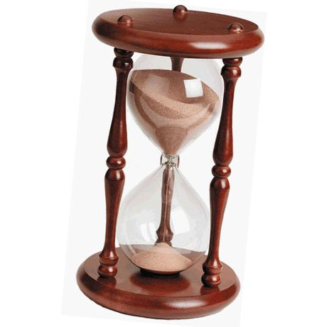

The Present Tense
An infinitive is a verb found in its original form, which is located in the dictionary. They can end in either –er, –re or –ir. To conjugate means that you need to change the verb from the infinitive to the person doing the action. Remove the ending from the infinitive and add the new ending following the patterns listed below.
Regular verb conjugations follow this pattern:
–er –re –ir *
I - je -e - (none) -is
you (s) - tu -es -s -is
he/she – il/elle -e - (none) -it
we - nous -ons -ons -issons
you (pl) - vous -ez -ez -issez
they – ils/elles -ent -ent -issent

* - there are lots of irregular ‘–ir’ verbs in French, so it is always best to check for irregulars!

Examples:
- habiter (–er verb)
we live nous habitons
- vendre (–re verb)
he sells il vend
- remplir (–ir verb)
they fill ils remplissent

+
infinitive
e.g. regarder
Examples:
- I am going to play football
Je vais jouer au foot.

- We are going to watch TV Nous allons regarder la téle.
The Near Future Tense
The near future tense is used to say something that you are going to do. You should use a future time phrase with this tense.
To form the future tense:
- Take the present tense of the verb ‘aller’
- Add the infinitive
aller
I am going je vais
you (s) are going tu vas
he/she is going il /elle va
we are going nous allons
you (pl) are going vous allez
they are going ils/ells vont

